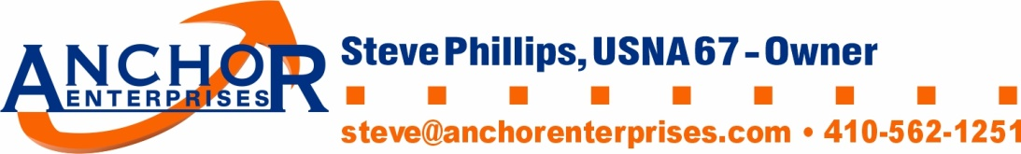
Anchor Enterprises
Refund Policy
Refunds for any item received can be requested. All refund requests must be done via email (usna@anchorenterprises.com).
Anchor Enterprises must be notified of the request for a refund within 10 days of receipt of the item. In order to receive a refund, merchandise items must be returned within 10 days of notification.
Return the item in new condition to:
Anchor Enterprises
8606 Wintergreen Court #106
Odenton, MD 21113

If the item in question was damaged or not the item ordered, Anchor Enterprises will pay for the shipping cost to the customer and the shipping cost of the returned items. If the refund is being requested due to the customer ordering incorrect item, size, or color, the customer must pay for the shipping cost of the item to the customer, and the return shipping cost. If the refund is being requested due to the customer ordering incorrect item, size, or color, the customer must pay a restocking fee of $15.00 per item.

